Application Pack



|  |  |
| --- | --- |
| Post title |  |
| Closing date |  |
| Where did you hear about this post? |  |

Please read JOB APPLICATION GUIDANCE carefully prior to completing this form.

Please use dark ink or typescript as it will be necessary to photocopy your application.

|  |  |  |  |
| --- | --- | --- | --- |
| 1. **Personal details** | | | |
| Last name |  | | |
| First name(s) |  | | |
| Also known as |  | | |
| Address |  | | |
|  | Postcode |  |
| Email address |  | Phone |  |

|  |  |  |  |  |
| --- | --- | --- | --- | --- |
| 1. **Right to Work** | | | | |
| Are you eligible to work in the UK? | Yes |  | No |  |
| Are there any restrictions on your ability to work in the UK? | Yes |  | No |  |
| If yes, please give details | | | | |
|  | | | | |

1. **Qualifications and training**

Please indicate details of any qualifications or training courses undertaken, and membership of any professional bodies which you consider relevant to this post.

Original certificates / documents will be required prior to appointment.

|  |  |
| --- | --- |
| **(a) School Qualifications** | **Qualification / Grade** |
|  |  |
| **(b) Further Education Qualifications** | **Qualification / Grade** |
|  |  |
| **(c) Professional Qualifications** | **Qualification / Grade** |
|  |  |
| **(d) Other Training Relevant to the Post** | **Qualification / Grade** |
|  |  |

1. **Employment history**

Please list your employment history, starting with your current / most recent employment, accounting for any gaps in employment.

|  |  |
| --- | --- |
| Company name |  |
| Address |  |
| Nature of business |  |
| Position held |  |
| Date started |  |
| Date left |  |
| Reason for leaving |  |
| Salary |  |
| Notice period |  |
| Brief description of duties |  |

|  |  |
| --- | --- |
| Company name |  |
| Position held |  |
| Date started |  |
| Date left |  |
| Reason for leaving |  |
| Salary |  |
| Brief description of duties |  |

|  |  |
| --- | --- |
| Company name |  |
| Position held |  |
| Date started |  |
| Date left |  |
| Reason for leaving |  |
| Salary |  |
| Brief description of duties |  |

|  |  |
| --- | --- |
| Company name |  |
| Position held |  |
| Date started |  |
| Date left |  |
| Reason for leaving |  |
| Salary |  |
| Brief description of duties |  |

|  |  |
| --- | --- |
| Company name |  |
| Position held |  |
| Date started |  |
| Date left |  |
| Reason for leaving |  |
| Salary |  |
| Brief description of duties |  |

Please continue on another sheet if necessary.

Langstane Housing Association reserves the right to contact any of your previous employers with your prior permission.

1. **Supporting statement**

Before completing this section, please refer to the Job Application Guidance.

|  |
| --- |
| Please continue on another sheet if necessary. |

1. **Disability**

Langstane Housing Association supports the guaranteed job interview scheme which guarantees an applicant with, or who considers themselves to have, a disability an interview if they meet the essential criteria for the post advertised.

|  |  |  |  |
| --- | --- | --- | --- |
| Do you wish to be considered under this scheme? | | Yes | No |
| Are there any adjustments that may be required should you be invited for interview? | | Yes | No |
| If yes, what adjustments are required |  | | |

1. **Canvassing / Relationships**

Canvassing of Board Members, or employees of The Langstane Group, either directly or indirectly, will disqualify your application. Please give details of any Board Member or employee of the Langstane Group to whom you are related, is your partner, or you have a close friendship with.

|  |  |
| --- | --- |
| Name of person |  |
| Position in organisation |  |
| Nature of relationship |  |

1. **References**

It is normal practice for Langstane Housing Association to approach the referees of candidates shortlisted for employment. Please give the name of two referees, one of whom should be your current / most recent employer (please note that references will not be taken up before interview stage).

|  |  |  |  |
| --- | --- | --- | --- |
| **Referee 1** | | **Referee 2** | |
| Name |  | Name |  |
| Title |  | Title |  |
| Organisation |  | Organisation |  |
| Address |  | Address |  |
|  |  |
| Email |  | Email |  |
| Phone No. |  | Phone No. |  |
| Relationship to you (e.g. line manager) |  | Relationship to you (e.g. line manager) |  |

If you are known to your referee by a different name, please indicate which referee and by what name you are known to them.

All offers of employment are subject to satisfactory reference responses. If you are recommended for appointment, your employer will be approached for a reference prior to employment.

1. **Availability**

If you were offered the post, when would you be able to start?

..............................................................................................................................................................................

1. **Rehabilitation of Offenders Act 1974**

Certain posts, because of the nature of the work, are exempt from the provisions of Section 4(2) of the Rehabilitation of Offenders Act 1974 (Exemptions) Order 1975. Applicants are, therefore, not entitled to withhold information about convictions which for other purposes are “spent” under the provisions of the Act and, in the event of employment, any failure to disclose such convictions could result in dismissal or disciplinary actions by Langstane Housing Association Limited. Applicable applicants are asked to complete a Criminal Record Declaration Form, information given will be confidential and will be considered only in relation to an application for positions to which the order applies.

1. **Fair Processing of Date**

By signing and returning this Application Form, you agree that you have seen and read Langstane Housing Association Limited’s Privacy Notice, which sets out what data Langstane Housing Association Limited holds and why, how it is used, who it may be shared with, and your rights in relation to this data. If you would like to find out more about Langstane Housing Association’s Privacy Policies, please go to <https://www.langstane-ha.co.uk/data/Privacy_Policy>

1. **Declaration**

I believe the above information to be correct and confirm all relevant sections have been completed. I understand and accept the information may be checked and any false statement or deliberate omission of information may disqualify me from appointment or render me liable to dismissal if discovered after appointment.

|  |  |  |  |
| --- | --- | --- | --- |
| Signed |  | Date |  |

**Please note that if this document is returned electronically, you will be required to sign your application form at interview stage.**

|  |  |
| --- | --- |
| Completed application forms should be returned to:  **‘Private & Confidential’**  Human Resource  Langstane Housing Association  680 King Street  Aberdeen  AB24 1SL  Telephone No.: 01224 423000 (reception)  Email: [recruitment@langstane-ha.co.uk](mailto:recruitment@langstane-ha.co.uk) | A logo for a housing association  Description automatically generated  Image result for disability confient logoo |





Job Application Guidance



Thank you for your interest in working at Langstane Housing Association.

Please read the following guidance note, which has been written to assist you in the completion of your application.

## General

For applicants with a disability, details of all posts will be made available on request, in Braille, in large print or on tape, and applications may be submitted on disk or in an alternative format. Please contact our Human Resources team for more details.

Human Resources   
680 King Street

Aberdeen

AB24 1SL

Telephone No.: 01224 423000 - Reception

Email: [recruitment@langstane-ha.co.uk](mailto:recruitment@langstane-ha.co.uk)

A separate application form must be completed for each post you apply for. **Please note CVs are not accepted**. If you are filling in the application by hand, please complete it in dark ink. If you are completing the form electronically, please keep to the format in the form and do not change any of the fields. If you return a completed application form back to us by email you may be required to sign your application form at the interview stage. Applications must be received by the closing time and date. Late applications will not be considered.

The application form plays a very important part in the selection process, and will be used as the basis for shortlisting you for a job. Particular attention is given to the essential and desirable criteria as set out in the job description and / or person specification. Therefore you are advised to highlight, by giving examples, how your experience and skills match the requirements of the post. You must fill in all sections of the form, making sure the information you provide is clear and accurate. The information you provide will be treated as confidential and stored in accordance with the Data Protection Act 1998.

Please send your application back as soon as possible. We advise that you take a copy of your form for future reference should you be invited for interview.

1. **Personal details**

Please provide a telephone number and email address on which you may be contacted.

1. **Asylum & Immigration Act 1996**

The Immigration, Asylum and Nationality Act 2006 makes it an offence to employ anyone who is not entitled to live or work in the UK. All applicants selected for interview will be required to provide evidence that they are entitled to live and work in the UK. Appropriate documentation may include the original of your current passport, birth or marriage certificate or P60/45.

1. **Qualifications and training**

Refer to the job description and person specification and provide details of any qualifications, apprenticeships, training or courses etc., which are **relevant** to the job. You will be required to provide evidence of your original qualification certificates at the interview stage.

When providing details of school or further education qualifications, please remember to specify the level of qualification undertaken (i.e. O Level, National 5, Higher grade) and the grade achieved.

1. **Employment history**

Please provide details of your employment history to date, starting with your current or most recent post and accounting for any periods of time since leaving school not spent in employment, e.g. Full time education or other circumstances. For posts held within the last three years, please confirm final salary / wage details.

1. **Supporting statement**

This section is very important as the information you provide will be the basis for deciding who will be invited to interview. Before completing this section, have a close look at the Job Description and think carefully about why you are suitable for this post, relating your skills, knowledge and experience to the duties of the post as fully as possible. Then take the Person Specification and go through each criteria point by point, writing a clear example of how you meet each requirement.

The example you give may be from your current job or from an activity you have done in the past. Remember that relevant experience is not always obtained in a formal work setting, so (particularly if you have never been in paid employment or have not worked for a long time) consider any voluntary work, courses, student placement, leisure activities or other activities taken.

When completing this section of the form, try to list your examples in the order they appear in the Person Specification, as this will help when we are shortlisting. Do ensure you mention all relevant experience as we cannot assume anything from a job title you may have had in the past.

Feel free to continue on a separate A4 sheet if you need more room but don’t forget to put your name on it and the title of the post you are applying for.

Please do not insert all or part of your CV to support this statement as it will not be taken into consideration during the selection process.

1. **Equal opportunities**

In order to assist Langstane Housing Association in monitoring the effectiveness of its equal opportunities policy, please complete the equal opportunities monitoring form. The information is kept separate to your application form and is kept by our Human Resource team.

Use this form to tell us if you consider yourself to have a disability and to also give details of any facilities you may require to allow you to fully participate at interview.

If you are disabled and meet the essential criteria for the post you will be guaranteed an interview. In this case the panel conducting the shortlisting will be advised accordingly. Alternatively, you may choose not to accept this option and enter the shortlisting process without the panel being aware of your disability.

Selection for interview will then be in open competition with all other applicants.

1. **Canvassing / Relationships**

We ask if you are related to, or close friends with, a Board Member or employee of the Langstane Group (Langstane Housing Association and its wholly owned subsidiary companies) either directly or indirectly. If you are, we need to know in order to make sure there is no conflict of interest present during the recruitment process.

1. **References**

All external applicants are asked whenever possible to provide names of two employment referees. Internal applicants only require the name of one referee. Please provide the names of people who may be approached to provide a reference who hold / have held a more senior position to you and one to which you reported directly.

Referees will be asked to confirm some of the information you provide in your application and to give their opinion on your suitability for the post. Your referees must not be friends or family members.

One of your referees must be your present or most recent employer, unless you have not worked in paid employment. If this is the case, you may provide the name and address of anyone who knows you well. If you are a School or College leaver you should provide the name of a teacher / tutor / guidance teacher.

Your second referee may be either someone else from your present employer or someone from a previous employer.

A character reference will only be accepted where it is not reasonably practicable to provide an employment reference. Please highlight on the application form if a referee is to provide a character reference.

References are requested for successful candidates following interview.

1. **Availability**

Please give an indication of when you would be able to start work with us if offered the job.

1. **Disclosure check**

Successful candidates may be required to obtain clearance from Disclosure Scotland (if relevant to post). A criminal record will not necessarily debar an applicant from working with Langstane Housing Association. Decisions regarding suitability for a position which is subject to vetting will be dependent on the nature of the position, together with the circumstances and background of the offence/s.

If you are invited to interview, the interview panel will be given details of any relevant information.





Equal Opportunities Monitoring Form

**The information you provide on this form is held securely and confidentially by our Human Resource Team who will ensure all applications for employment are treated equally before confidentially destroying the completed form once a selection decision is made.**

|  |  |
| --- | --- |
| **Full name** |  |
| **Post applied for** |  |

|  |
| --- |
| **Equal Opportunities Form** |
| Langstane Housing Association Ltd embraces its diversity and has a zero tolerance to any forms of discrimination.  **Completing this form is voluntary** but it will help us to understand the diversity of our applicants and to provide anonymous information for monitoring purposes.  Please tick the relevant box / complete with the relevant information. |

|  |  |  |  |
| --- | --- | --- | --- |
| **Gender** |  | **Age** |  |

|  |  |  |  |  |
| --- | --- | --- | --- | --- |
| **Disability** | | | | |
| Under the Equality Act 2010 you are regarded as having a disability if you have a long term physical or mental impairment which **affects your ability to carry out normal day to day activities**. In the workplace such activities are taken to include things like using a telephone or computer, interacting with colleagues, following instruction, driving and carrying everyday objects, although some roles may include other activities. Long term is defined as lasting 12 months or more. | | | | |
| Are you disabled? | | Yes | No | Prefer not to say |
|  | | | | |
| **Nationality** | | | | |
| Please specify |  | | | |

|  |  |  |  |  |  |  |  |
| --- | --- | --- | --- | --- | --- | --- | --- |
| **Religion** | | | | | | | |
| Christian |  | Hindu |  | Muslim |  | Another |  |
| Buddhist |  | Jewish |  | Sikh |  | No religion |  |

|  |  |  |  |  |  |  |  |
| --- | --- | --- | --- | --- | --- | --- | --- |
| **Ethnic group** | | | | | | | |
| The ethnic origin information we ask is based on the Scottish Government and General Register Office for Scotland official Ethnicity Classification for Scottish Official Statistics. Please chose the category identify as in relation to your ethnic or cultural background. | | | | | | | |
| **White** | | **Black** | | **Asian** | |  | |
| Scottish |  | Caribbean |  | Indian |  | Mixed |  |
| Other British |  | African |  | Pakistani |  | Other |  |
| Irish |  | Any other |  | Bangladeshi |  |  | |
| Gypsy/ Traveller |  |  | | Chinese |  |
| Polish |  | Any other |  |
| Any Other |  |  | | | |

Thank you for completing this form.



Criminal Record Declaration Form



**Statement on recruiting applicants with a criminal record**

Applicants are required to declare all unspent convictions and conditional cautions, some posts may require Disclosure Check

For further information and guidance please visit : <https://www.mygov.scot/disclosure-types>

We recognise the contribution that people with criminal records can make as employees and volunteers and welcome applications from them. A person’s criminal record will not, in itself, debar that person from being appointed to this post. Any information given will be treated in the strictest confidence. Suitable applicants will not be refused posts because of offences which are not relevant to, and do not place them at or make them a risk in, the role for which they are applying.

All cases will be examined on an individual basis and will take the following into consideration:

* Whether the conviction is relevant to the position applied for.
* The seriousness of any offence revealed.
* Your age at the time of the offence(s).
* The length of time since the offence(s) occurred.
* Whether the applicant has a pattern of offending behaviour.
* The circumstances surrounding the offence(s), and the explanation(s) provided.
* Whether your circumstances have changed since the offending behaviour.

It is important that applicants understand that deliberate attempts to conceal the information requested in this form could result in disciplinary proceedings or dismissal.

Further advice and guidance on disclosing criminal records can be obtained on <https://www.mygov.scot/disclosure-types>

|  |  |  |
| --- | --- | --- |
| **Criminal Record Declaration Form** | | |
| Do you have any unspent convictions or conditional cautions, as defined by the Rehabilitation of Offenders Act 1974. | Yes | No |
| If you have answered yes, there are options available for disclosing your criminal record.  **Option 1:**  You can disclose your criminal record on a separate sheet provided that you mark a cross on the line below and attach the details in an envelope stapled to this form. The envelope should be marked CONFIDENTIAL and state your name and details of the post.  I have attached details of my conviction separately (please mark with an X if appropriate.)  **Option 2:**  Please provide details in the space below | | |

|  |  |
| --- | --- |
| **Declaration** | |
| I declare that the information provided on this form is correct. I understand that the declaration of criminal record will not necessarily prevent me from being offered this role at Langstane Housing Association. | |
| Print name |  |
| Signed |  |
| Date |  |

Privacy Notice

This document outlines Langstane Housing Association’s duties in controlling and processing data, and how this data will be managed. Langstane Housing Association’s data protection responsibilities are laid out in the General Data Protection Regulation (EU) 2016/679 (the GDPR), the Data Protection Act 2018 and other associated legislation, regulations, regulatory guidance, and good practice.

### What we need

Langstane Housing Association (LHA) will be a "controller" of the personal information that you provide to us in completing Langstane Housing Association’s Job Application Form, and any subsequent data provided to, or produced by, Langstane Housing Association in the course of your employment with Langstane Housing Association, unless otherwise stated in this privacy notice.

When you apply for a job with Langstane Housing Association, and during the course of your employment, we will ask you for the following personal information:

* contact details – name, address, phone number, email address, National Insurance number, date of birth;
* details of past employment and qualifications – place of work/study, role/course description, dates, reference details;
* emergency contact details – their name, address and phone number for health and safety reasons;
* declarations of interest – as set out in Langstane Housing Association’s Entitlement’s, Payments and Benefits Policy;
* equality information – age, marital status, gender, sexual orientation, ethnic origin, religion and belief, disability;
* criminal convictions – including a Disclosure Scotland check, and a full PVG where relevant for your role;
* health information– this may include a pre-employment health questionnaire, and any return to work sickness forms (with accompanying information where required, including letter/reports from medical professionals) completed in the course of your employment;
* evidence of your right to work in the UK – which could include a copy of a passport;
* evidence of your right to drive – copy of driving license, vehicle registration, vehicle MOT details, vehicle ownership details, copy of vehicle insurance certificate;
* payroll details – bank account number, sort code, salary, pay slips;
* the date of birth of any children for whom you have taken parental leave; and
* other information that may result from your employment with Langstane Housing Association – including sickness records, disciplinary records and personal development reviews.

### Why we need your personal information – contractual purposes

We need to collect your personal information so that we can assess your application for, and administer any contract of, employment with Langstane Housing Association. This may also involve confirming the information provided in your application form is correct, and obtaining information from the references that you have provided which is relevant to your application.

We will also use your data to confirm your right to work in the UK, and, where relevant to your role, confirm your right to drive, including that your vehicle is properly insured and registered.

We will use your personal information to carry out Langstane Housing Association’s obligations under your contract of employment and ensure you comply with your responsibilities under this contract.

If you do not provide us with all of the personal information that we need to collect, this may affect our ability to assess your application for employment with Langstane Housing Association.

### Why we need your personal information – legal obligations

We are under a legal obligation to process certain personal information relating to our employees for the purposes of complying with our obligations under:

* the Protection of Vulnerable Groups (Scotland) Act 2007 to check that our employees are able to undertake regulated work with children and vulnerable adults;
* the Equality Act 2010, which requires us to process personal information to make reasonable adjustments where necessary;
* the Housing (Scotland) Act 2010, which requires us to report certain statistical data on our employees to the Scottish Housing Regulator;
* the Statistics of Trade Act 1947 Act, which requires us to provide certain statistical data on our employees to the Office for National Statistics; and
* the Maternity and Parental Leave etc. Regulations 1999 (as amended by the Parental Leave (EU Directive) Regulations 2013) to ensure that entitlement to parental leave is tracked and passed on to any future employer(s) on request.

### Why we need your personal information – legitimate purposes

We also process your personal information in pursuit of our legitimate interests to issue communications to you related to your job at Langstane Housing Association, and keep you informed about Langstane Housing Association in general.

Where we process your personal information in pursuit of our legitimate interests, you have the right to object to us using your personal information for the above purposes. If you wish to object to any of the above processing, please contact us by emailing us at governance@langstane-ha.co.uk, or writing to us at Langstane Housing Association, 680 King Street, Aberdeen, AB24 1SL.

If we agree and comply with your objection, this may affect our ability to undertake the tasks above for the benefit of your application and/or employment with Langstane Housing Association.

### Why we need your personal information – equality monitoring requirements

We use your personal information relating to your age, marital status, gender, sexual orientation, ethnic origin, religion and belief and disability to help us identify and keep under review the existence or absence of equality of opportunity or treatment between groups of people within the same categories to promote or maintain equality within Langstane Housing Association.

### Other uses of your personal information

We may ask you if we can process your personal information for additional purposes. Where we do so, we will provide you with an additional privacy notice with information on how we will use your information for these additional purposes.

### Who we share your personal information with

We may be required to share personal information with statutory or regulatory authorities and organisations to comply with statutory obligations. Such organisations include the Health & Safety Executive, when we are required under the Reporting of Injuries, Diseases and Dangerous Occurrences Regulations 2013 (RIDDOR), and HMRC for tax purposes. Depending on your role at Langstane Housing Association, we may also be required to send your details to the Gas Safe Register in accordance with the Gas Safety (Installation and Use) Regulations 1998.

If you are completing an apprenticeship, we will be required to share your personal details with your apprenticeship’s governing body for the purposes of registration with the relevant organisation.

We may also share your name (and work contact details) with third party training providers to allow you to access to training relevant to your role at Langstane Housing Association.

We may also share personal information with our professional and legal advisors for the purposes of taking advice.

Depending on your role, some employees working for Langstane Housing Association are required to have a basic Disclosure Scotland check carried out. Employees will be asked to provide their personal details directly to Disclosure Scotland and provide Langstane Housing Association with the outcome of the check. In these circumstances, Disclosure Scotland will become the “controller” of your personal data. Disclosure Scotland is an agency of the Scottish Government, operating under the Police Act 1997 and the PVG Scheme Act 2007, and they have their own Data Protection and Privacy Statement.

For certain roles, a full PVG Scheme Membership (from Disclosure Scotland) is required (where relevant, this will be advertised in the job description). If this applies to you, you will be asked to complete the PVG application form. Once this information has been received by Disclosure Scotland, they will become the “controller” of your personal data. Disclosure Scotland is an agency of the Scottish Government, operating under the Police Act 1997 and the PVG Scheme Act 2007, and they have their own Data Protection and Privacy Statement.

Langstane Housing Association employs third party suppliers to provide services for our employees, specifically in relation to payroll, pensions, life insurance and occupational health services. These suppliers may process personal information on our behalf as "processors" and are subject to written contractual conditions to only process that personal information under our instructions and protect it. In the case of Langstane Housing Association’s pension provider, they will also act as the “controller” of your information once it is transferred to them.

In the event that we do share personal information with external third parties, we will only share such personal information strictly required for the specific purposes and take reasonable steps to ensure that recipients shall only process the disclosed personal information in accordance with those purposes.

### How we protect your personal information

Your personal information is stored in our electronic filing system and our servers based in the UK. This is accessed by our employees for the purposes set out above. Where hard copies of documentation are retained, in line with Langstane Housing Association’s data retention schedule, these will be stored securely at Langstane Housing Association’s Head Office (or secure offsite storage).

We will not ordinarily transfer your data outwith the EU. If this position changes and your personal information is proposed to be transferred outwith the EU, we will provide you with information regarding the safeguards we have put in place with the recipient country to protect your personal information.

**How long we keep your personal information**

We will only keep your personal information for as long as necessary to comply with our employment law obligations and to safeguard Langstane Housing Association in the event of any claims, complaints, litigation, enquiries or investigations during or following the termination of your employment.

Unless you ask us not to, we will review and possibly delete your personal information 6 years after the cessation of your employment with Langstane Housing Association. Where your job application has been unsuccessful, we will retain your personal information for 1 year after you have been notified of this.

Where you have taken parental leave during your employment with Langstane Housing Association, a record of this will be kept until the relevant child’s 18th birthday. This will only include your name, the child’s date of birth, and the dates of the parental leave taken.

We may keep certain personal information of employees for longer in order to confirm your identity and how long you were an employee of Langstane Housing Association. We need to do this to in the event of a claim against Langstane Housing Association.

We have a data retention schedule that sets out the periods for retaining and reviewing all information that we hold. This sets out different retention periods and you can request a copy by emailing us at emailing us at [governance@langstane-ha.co.uk](mailto:governance@langstane-ha.co.uk), or writing to us at Langstane Housing Association, 680 King Street, Aberdeen, AB24 1SL.

### Your rights

You can exercise any of the following rights by emailing us at [governance@langstane-ha.co.uk](mailto:governance@langstane-ha.co.uk), or writing to us at Langstane Housing Association, 680 King Street, Aberdeen, AB24 1SL.

Your rights in relation to your personal information are:

* you have a right to request access to the personal information that we hold about you by making a "subject access request";
* if you believe that any of your personal information is inaccurate or incomplete, you have a right to request that we correct or complete your personal information;
* you have a right to request that we restrict the processing of your personal information for specific purposes; and
* if you wish us to delete your personal information, you may request that we do so.

Any requests received by Langstane Housing Association will be considered under applicable data protection legislation. If you remain dissatisfied, you have a right to raise a complaint with the Information Commissioner's Office at [www.ico.org.uk](http://www.ico.org.uk/)

Employee benefits

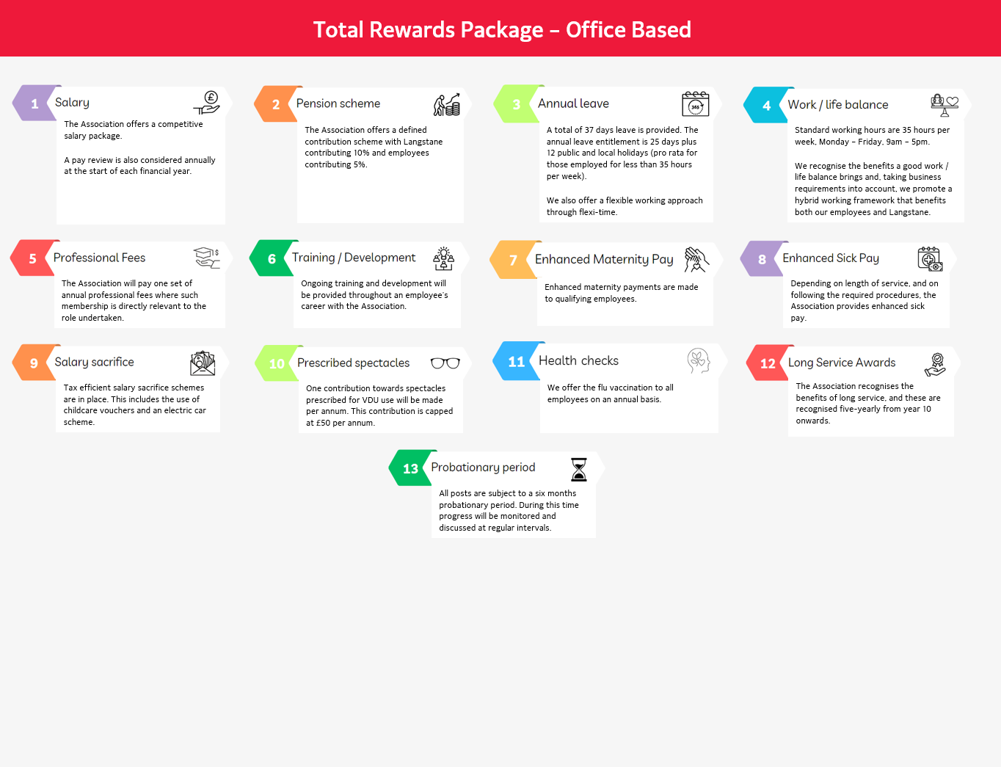

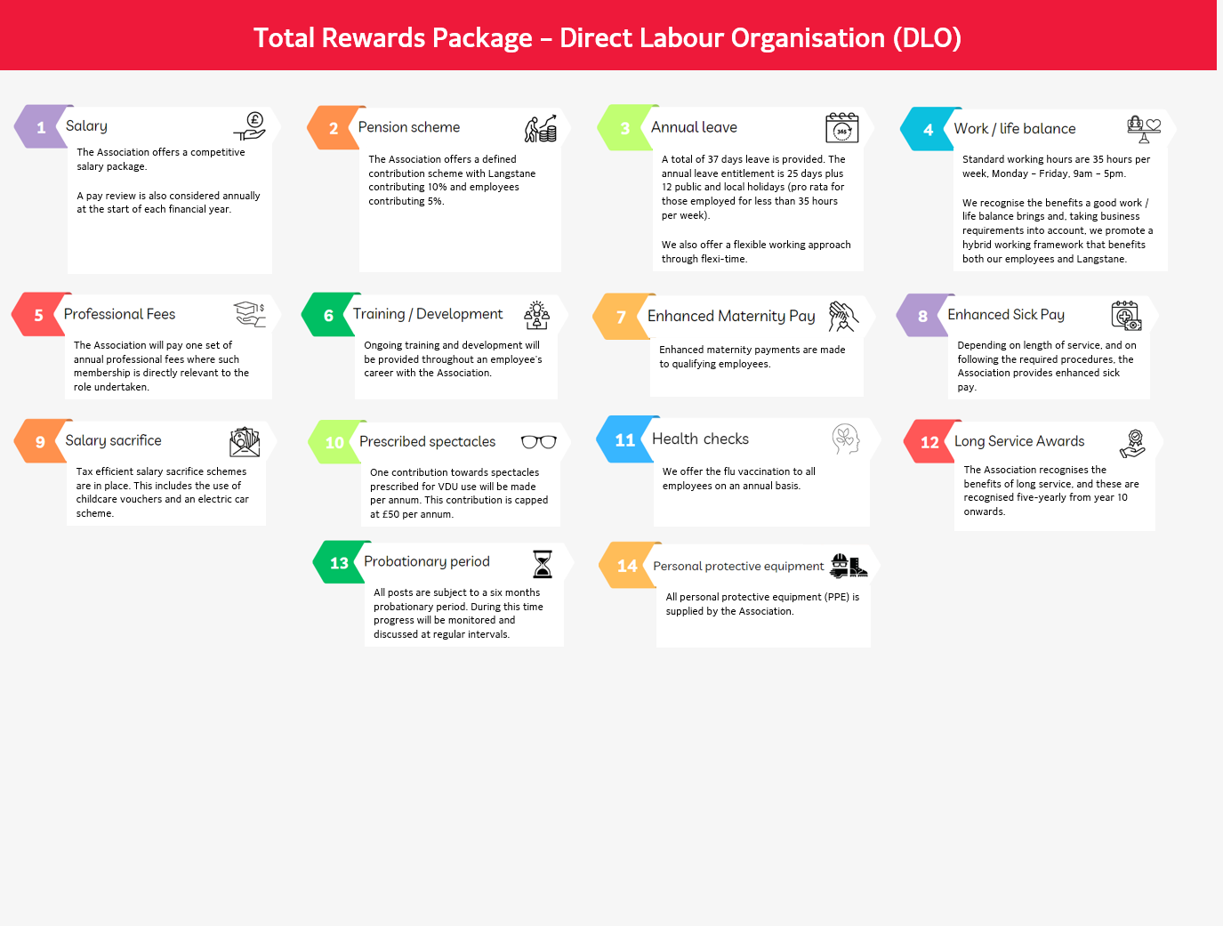



[https://www.linkedin.com/langstaneHA](https://www.linkedin.com/company/langstane-housing-association/mycompany/)

<https://www.facebook.com/Langstane>

[www.langstane-ha.co.uk](http://www.langstane-ha.co.uk)